Contents
1. What is Apache Kafka and what is the use? 2
2. What is features of Kafka? 2
3. What is a producer, consumer, cluster, broker, topic, partition, offset, consumer group and zookeeper in kafka? 3
4. What is a producer in kafka? 3
5. What is a consumer in kafka? 3
6. What is a broker in kafka? 4
7. What is a cluster in kafka? 5
8. What is a topic in kafka? 5
9. What is a partition in kafka? 5
10. What is offset in kafka? 5
11. What is a consumer group in kafka? 6
12. What is a Zookeeper in kafka? 6

What is Apache Kafka and what is the use?
What is Kafka?
Apache Kafka is a distributed data store optimized for ingesting and processing streaming data in real-time. Streaming data is data that is continuously generated by thousands of data sources, which typically send the data records in simultaneously. A streaming platform needs to handle this constant influx of data, and process the data sequentially and incrementally.
Kafka provides three main functions to its users:
- Publish and subscribe to streams of records
- Effectively store streams of records in the order in which records were generated
- Process streams of records in real time
Kafka is primarily used to build real-time streaming data pipelines and applications that adapt to the data streams. It combines messaging, storage, and stream processing to allow storage and analysis of both historical and real-time data.
What is Kafka used for?
Kafka is used to build real-time streaming data pipelines and real-time streaming applications. A data pipeline reliably processes and moves data from one system to another, and a streaming application is an application that consumes streams of data. For example, if you want to create a data pipeline that takes in user activity data to track how people use your website in real-time, Kafka would be used to ingest and store streaming data while serving reads for the applications powering the data pipeline. Kafka is also often used as a message broker solution, which is a platform that processes and mediates communication between two applications.
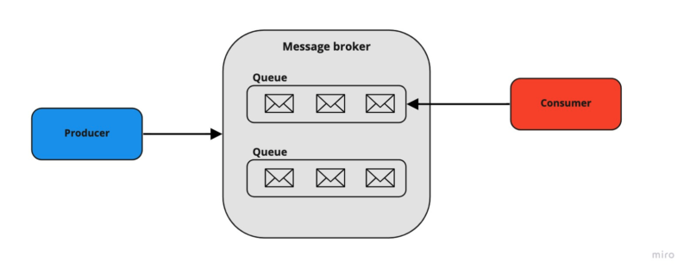
Resources: https://aws.amazon.com/what-is/apache-kafka/

What is features of Kafka?
1. Scalable
Kafka’s partitioned log model enables data to be split into multiple partitions and distributed across servers. This horizontal scaling means Kafka can handle massive data volumes beyond the capacity of a single machine, making it ideal for high-throughput systems.
2. Fast
Kafka decouples producers and consumers using a publish-subscribe model, which allows data to flow asynchronously with very low latency. This design makes Kafka extremely fast and capable of processing millions of events per second.
3. Durable & Fault-Tolerant
Kafka ensures durability by persisting all messages to disk and replicating partitions across multiple brokers. Even if a server fails, the data remains safe and available, providing strong reliability guarantees.
4. Real-Time Streaming Support
Beyond batch processing, Kafka supports real-time event streaming, making it suitable for applications like payment processing, fraud detection, and monitoring systems.
5. High Throughput with Backpressure Handling
Kafka can handle high message throughput while balancing load across consumers. Its design ensures consumers can read at their own pace without overwhelming downstream systems.

What is a producer, consumer, cluster, broker, topic, partition, offset, consumer group and zookeeper in kafka?
Resources: https://www.youtube.com/watch?v=HUAa1Yg9NlI&list=PLVz2XdJiJQxwpWGoNokohsSW2CysI6lDc&index=2

What is a producer in kafka?
Apache Kafka Producer is a client application within the Apache Kafka ecosystem for sending (or producing) information to Kafka topics. It is essential for the creation of real-time data pipelines and event-driven architectures. After the data has been sent to a topic, it is then ready for other services or for Kafka consumers to read and process.
Kafka Producers are high-throughput, low-latency, meaning that they can send millions of messages per second with very little latency. They also provide features such as asynchronous send, batching, retries, and serialization of messages, making them incredibly powerful for new streaming apps, IoT telemetry data, e-commerce analytics, and financial platforms.
Resources: https://www.geeksforgeeks.org/apache-kafka/introduction-to-apache-kafka-producer/

What is a consumer in kafka?
Kafka Consumers is used to reading data from a topic and remember a topic again is identified by its name. So the consumers are smart enough and they will know which broker to read from and which partitions to read from. And in case of broker failures, the consumers know how to recover and this is again a good property of Apache Kafka. Now data for the consumers is going to be read in order within each partition. Now please refer to the below image. So if we look at a Consumer consuming from Topic-A/Partition-0, then it will first read the message 0, then 1, then 2, then 3, all the way up to message 11. If another consumer is reading from two partitions for example Partition-1 and Partition-2, is going to read both partitions in order. It could be with them at the same time but from within a partition the data is going to be read in order but across partitions, we have no way of saying which one is going to be read first or second and this is why there is no ordering across partitions in Apache Kafka.
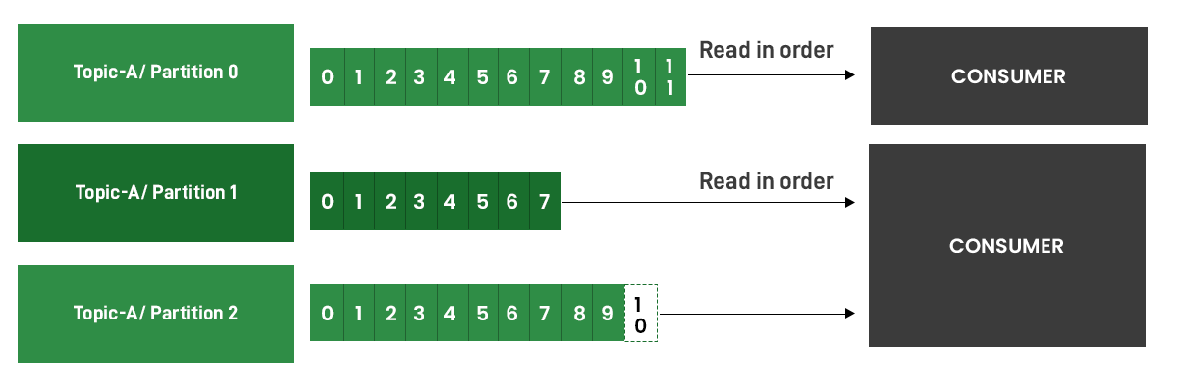
Resources: https://www.geeksforgeeks.org/java/apache-kafka-consumer/

What is a broker in kafka?
A Kafka broker is like a helper that lets information go between those who send information (producers) and those who receive information (consumers). The broker handles all requests to write new information and read existing information. The Kafka cluster is the group of one or more Kafka brokers working together. Each broker in the cluster has its own unique number ID. For example lets say we have the cluster of the 3 Kafka brokers. Each of these 3 brokers has its own special number ID that is different from the others.

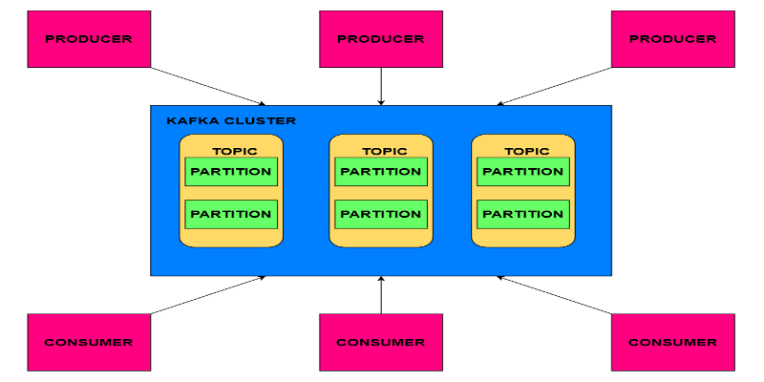
Resources: https://www.geeksforgeeks.org/cloud-computing/what-is-a-kafka-broker/

What is a cluster in kafka?
A Kafka cluster is a group of multiple Kafka brokers all working together. Having a cluster allows Kafka to handle very large amounts of data. If more data needs to be processed new brokers can easily be added to make the cluster bigger. If less data needs processing, brokers can be removed to make the cluster smaller.
Resources: https://www.geeksforgeeks.org/cloud-computing/what-is-a-kafka-broker/

What is a topic in kafka?
A topic is like a labelled box or category that related messages go into in Kafka. Producers publish their messages into a specific topic box. Consumers subscribe to one or more topic boxes to receive all the messages placed into those boxes. Using topics helps organize messages and allows parallel processing of different message categories.
Resources: https://www.geeksforgeeks.org/cloud-computing/what-is-a-kafka-broker/

What is a partition in kafka?
A partition is the smallest storage unit where the messages live inside the topic. The partitions have a significant effect on scalable message consumption. Each partition is an ordered and immutable sequence of records; meaning once a message is stored, it cannot be changed.
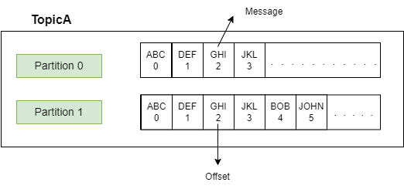
Resources: https://howtodoinjava.com/kafka/apache-kafka-tutorial/

What is offset in kafka?
Typically, Kafka consumers have 3 options to read the message from the partition:
- from-beginning – Always reads data from the start of the partition.
- latest – reads the messages produced after the consumer started.
- specific offset – reads the messages using a specific offset value.
Consumer offset represents the position or offset within a partition from which a consumer group has consumed messages. In other words, each consumer group maintains its offset for each partition it consumes. The offset helps in determining the next message to read from a specified partition inside the topic.
As soon as a consumer reads the message, Kafka automatically increments the offset value and commits the offsets, in a topic known as __consumer_offsets. This helps in case of machine failures. Consumer offsets behave like a bookmark for the consumer to start reading the messages from the point it left off.
Resources: https://howtodoinjava.com/kafka/apache-kafka-tutorial/

What is a consumer group in kafka?
Every consumer is always part of a consumer group. A consumer group represents a group of consumer instances that work together to consume messages from the specified topic(s). when a topic is created in Kafka, it can have one or more consumer groups associated with it. The consumer groups maintain the offset information for the partitions they consume.
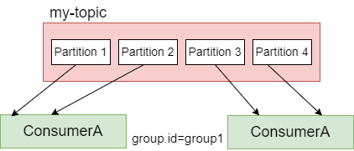

What is a Zookeeper in kafka?
In a Kafka ZooKeeper cluster, ZooKeeper is a centralized service that provides distributed coordination, names, and configuration information maintenance for applications that are executing in a distributed environment.
Apache Kafka makes use of Zookeeper to manage the following:
- In a Kafka ZooKeeper cluster, ZooKeeper tracks broker membership, topic configuration, leader selection, and metadata related to Kafka topics, brokers, and consumers.
- It stores the configuration of Kafka topics, stores the configuration of topics, and chooses leaders for each partition.
Resource: https://www.scaler.com/topics/kafka-tutorial/the-role-of-zookeeper-in-the-kafka-cluster/

